**34 РАЗВЕРТЫВАНИЕ WINDOWS ПРИЛОЖЕНИЯ**

Задание 1 Возьмите за основы проект Windows Forms и создайте установочный файл Setup.msi изучив Теоретический материал.

Листинг программы:

<?xml version="1.0" encoding="UTF-8"?>

<Wix xmlns="http://schemas.microsoft.com/wix/2006/wi">

<?define TargetDir=$(var.AppSample.TargetDir)?>

<?define ProductName=$(var.AppSample.ProjectName)?>

<?define TargetFileName=$(var.AppSample.TargetFileName)?>

<?define description="Демонстрация примера WiX"?>

<Product Id="{D5153F56-AD59-4A7F-BFC7-3DE60BAE1F63}" Name="$(var.ProductName)" Language="1058" Codepage="1251" Version="1.0.0"

Manufacturer="Sample Manufacturer" UpgradeCode="e5da6b60-8cf0-4850-b016-99478256a160" >

<Package InstallerVersion="200" Compressed="yes" InstallScope="perMachine" Description="$(var.description)" SummaryCodepage="1251"

Comments="Samokhin_SoftWare 2019" />

<MajorUpgrade DowngradeErrorMessage="A newer version of [ProductName] is already installed." />

<MediaTemplate EmbedCab="yes"/>

<Feature Id="ProductFeature" Title="InstallAppSaple" Level="1">

<ComponentRef Id="ProductComponents" />

<ComponentRef Id="ShortcutMenu"/>

<ComponentRef Id="ShortcutDesktop"/>

</Feature>

<Icon Id="del" SourceFile="del.ico"/>

<Property Id="ARPPRODUCTICON" Value="del" />

<CustomAction Id="LaunchInstalledExe" Directory="INSTALLFOLDER" Execute="immediate" Impersonate="yes"

Return="asyncNoWait" ExeCommand="[#$(var.TargetFileName)] -install" />

<InstallExecuteSequence>

<Custom Action='LaunchInstalledExe' After='InstallFinalize'/>

</InstallExecuteSequence>

</Product>

<Fragment>

<Directory Id="TARGETDIR" Name="SourceDir">

<Directory Id="ProgramFilesFolder">

<Directory Id="INSTALLFOLDER" Name="$(var.ProductName)" />

</Directory>

<Directory Id="DesktopFolder" Name="decktop"/>

<Directory Id="ProgramMenuFolder" Name="MenuFolder" >

<Directory Id="ApplicationProgramsFolder" Name="$(var.ProductName)" />

</Directory>

</Directory>

</Fragment

<Fragment>

<Component Id="ProductComponents" Guid="cc744989-749f-469e-897d-6ef75c7563ce" Directory="INSTALLFOLDER" >

<File Name="$(var.TargetFileName).config" Source="$(var.TargetDir)" />

<File Name="$(var.TargetFileName)" Source="$(var.TargetDir)"/>

</Component>

</Fragment>

<Fragment>

<Component Id="ShortcutMenu" Guid="{58066934-AC66-43B4-A674-85A8970DC3C5}" Directory="ApplicationProgramsFolder">

<Shortcut Id="StartMenu" Name="$(var.ProductName)" Description="$(var.description)" Target ="[INSTALLFOLDER]$(var.TargetFileName)" />

<RemoveFolder Id="RemoveShortcut" On="uninstall"/>

<Registry Root="HKCU" Key="SoftWare\[Manufacturer]\[ProductName]" Name="installed" Type="integer" Value="1" KeyPath="yes"/>

<Shortcut Id="UninstallProduct" Name="Удалить $(var.ProductName)" Target="[SystemFolder]msiexec.exe" Arguments="/uninstall [ProductCode]" Icon="del"/>

</Component>

</Fragment>

<Fragment>

<Component Id="ShortcutDesktop" Guid="{5B45E98F-6544-4A68-93F8-1D6FF0BD4E50}" Directory="DesktopFolder" >

<Shortcut Id="ShortcutDesktop" Name="$(var.ProductName)" Description="$(var.description)" Target ="[INSTALLFOLDER]$(var.TargetFileName)" />

<RemoveFolder Id="RemoveDesktopFolder" Directory="DesktopFolder" On="uninstall" />

<Registry Root="HKCU" Key="SoftWare\[Manufacturer]\[ProductName]" Name="installed" Type="integer" Value="1" KeyPath="yes"/>

</Component>

</Fragment>

</Wix>

Анализ результатов:

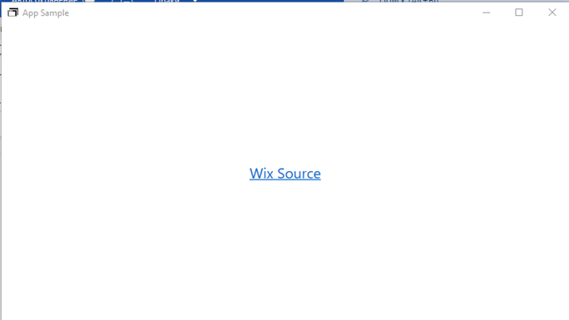

Рисунок 34.1 – Результат работы программы

Источник: собственная разработка